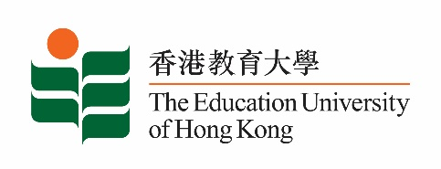
致： 传媒机构采访主任 (共 1页) 27 August 2021
To : News Editors (total: 1 pages)

香港教育大学2021年8月30日至9月12日可供采访之活动一览
The Education University of Hong Kong (EdUHK) Events Calendar for 30 August to 12 September 2021
本校诚邀 贵机构派员采访下列活动。传媒查询，请联络教大传讯处（电话：2948 6050）。
You are cordially invited to cover the events below. For media enquiries, please contact the Communications Office at 2948 6050.

因应2019冠状病毒疫情，以下活动或有人数限制，传媒请预先向主办部门登记。
In light of the COVID-19 pandemic, there may be restrictions on the number of participants for the following event(s). Please contact the respective organiser(s) / department(s) for prior registration.

- 教大大埔校园 （新界大埔露屏路十号） / EdUHK Tai Po Campus (10 Lo Ping Road, Tai Po, New Territories)

日期  Date | 时间  Time | 活动  Event | 地点  Venue | 主办部门及公众查询  Organiser &  Public Enquiry | 备注  Remarks
2021-09-01 -  2021-10-30 | 10 am - 7 pm | Zoran Poposki：光（个人画展）  Zoran Poposki: Glow (solo exhibition) | 教大大埔校园  文化与创意艺术学系展览厅（B2-P-01）  CCA Art Gallery,  EdUHK Tai Po Campus (B2-P-01) | 主办部门 / Organiser:  教大文化与创意艺术学系/  Department of Cultural and Creative Arts of EdUHK  查询 /Enquiries:  Dr Zoran Poposki  电邮 /Email:  zpoposki@eduhk.hk  电话 /Tel:  2948 7593 | 免费入场，  敬请预约。  Free admission.  By appointment.  详情/ Details: https://www.facebook.com/eduhkcca/photos/a.806934382699416/4452934904765994/

